**1. Toast**

MainActivity.java

package com.example.myapplication1;  
  
import androidx.appcompat.app.AppCompatActivity;  
import android.os.Bundle;  
import android.view.View;  
import android.widget.Button;  
import android.widget.EditText;  
import android.widget.Toast;  
  
public class MainActivity2 extends AppCompatActivity {  
  
 Button b;  
 EditText e;  
 @Override  
 protected void onCreate(Bundle savedInstanceState) {  
 super.onCreate(savedInstanceState);  
 setContentView(R.layout.*activity_main2*);  
 b=findViewById(R.id.*btn2*);  
 e=findViewById(R.id.*num*);  
 b.setOnClickListener(new View.OnClickListener() {  
 @Override  
 public void onClick(View v) {  
 Toast.*makeText*(MainActivity2.this, e.getText(), Toast.*LENGTH_SHORT*).show();  
  
 }  
 });  
 }  
}

activity_main.xml

<?xml version="1.0" encoding="utf-8"?>  
<LinearLayout xmlns:android="http://schemas.android.com/apk/res/android"  
 xmlns:app="http://schemas.android.com/apk/res-auto"  
 xmlns:tools="http://schemas.android.com/tools"  
 android:layout_width="match_parent"  
 android:layout_height="match_parent"  
 android:orientation="vertical"  
 tools:context=".MainActivity2">  
  
 <EditText  
 android:id="@+id/num"  
 android:layout_width="wrap_content"  
 android:layout_height="wrap_content"  
 android:hint="Enter a Number"  
 android:ems="10"  
 android:inputType="numberDecimal" />  
  
 <Button  
 android:id="@+id/btn2"  
 android:layout_width="wrap_content"  
 android:layout_height="wrap_content"  
 android:text="Click me" />  
  
  
</LinearLayout>

**Output**

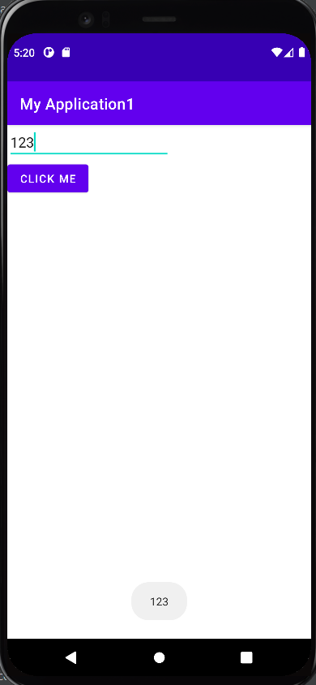

**2. Change image on button click**

MainActivity.java

package com.example.myapplication1;  
  
import androidx.appcompat.app.AppCompatActivity;  
import android.os.Bundle;  
import android.view.View;  
import android.widget.Button;  
import android.widget.ImageView;  
  
public class MainActivity extends AppCompatActivity {  
  
 Button b;  
 ImageView i;  
 @Override  
 protected void onCreate(Bundle savedInstanceState) {  
 super.onCreate(savedInstanceState);  
 setContentView(R.layout.*activity_main*);  
 b=findViewById(R.id.*btn*);  
 i=findViewById(R.id.*iv*);  
 b.setOnClickListener(new View.OnClickListener() {  
 @Override  
 public void onClick(View v) {  
 i.setImageResource(R.drawable.*pic2*);  
 }  
 });  
 }  
}

activity_main.xml

<?xml version="1.0" encoding="utf-8"?>  
<LinearLayout xmlns:android="http://schemas.android.com/apk/res/android"  
xmlns:app="http://schemas.android.com/apk/res-auto"  
xmlns:tools="http://schemas.android.com/tools"  
android:layout_width="match_parent"  
android:layout_height="match_parent"  
android:orientation="vertical"  
tools:context=".MainActivity">  
  
<ImageView  
 android:id="@+id/iv"  
 android:layout_width="match_parent"  
 android:layout_height="300dp"  
 android:src="@drawable/pic" />  
  
 <Button  
 android:id="@+id/btn"  
 android:layout_width="match_parent"  
 android:layout_height="52dp"  
 android:text="click me" />  
  
</LinearLayout>

**Output**

